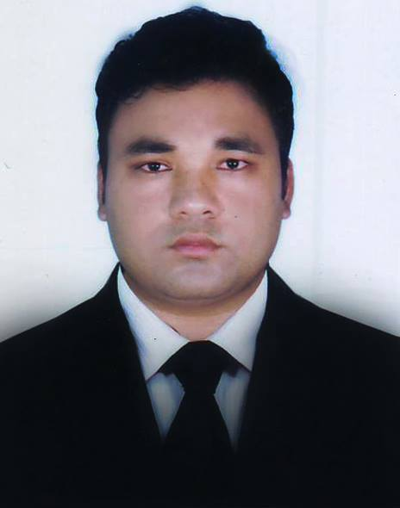**Resume of**

Uzzal Kumar Pramanik

B.Sc. in Computer Science & Engineering

Cell Phone: +8801737132307

Email: uzzal08cse@gmail.com

**Career Objective:**

My career objective is to grow up as a Software Developer and to serve to the highest contentment of the company through efficient development of business opportunity in Telecom Related arena. And actively contribute in dynamic environment as productive team player to build up a positive reputation and image of quality service.

**SKILL IN IT FIELD:**

**Job Experience: 3 .6 Years work in Advanced Software & It Services.**

**Programming Language**: C, C++, C#, Familiar with OOP.

**Database:** SQL, MySQL.

**Web Development**: HTML, CSS, Java Script, ASP.NET MVC.

**Framework Switch:** Quickly Learn any framework If company want.

**Design and Documentation:** Microsoft Office (Word, Excel, Power Point)

**TECHNOLOGY PROFICIENCY:**

Visual Studio.NET 2013, MSSQL Server 2012, Crystal Reports, RDLC Reports, WPF, WCF, Web Services

**Projects:**

* **Real Estate ERP.**
* **HR Management ERP**
* **Manufacturing ERP.**

**Language Skills:**

* Bengali (Mother tongue).
* English (Fluency in reading, writing and speaking).

**Specialty:**

* Friendly & Communicative.
* Eager to take challenge and possess a positive attitude.
* Like to take initiative. Able to work under pressure.
* Perceptive and interested to new technology.

**Educational Qualification:**

**Bachelor of Science in Computer Science and Engineering, Islamic University, Kushtia**

Passing Year: 2012(*Exam Held in 2014*)

**Result: 3.15 (Out of 4.00)**

**Higher Secondary Certificate (HSC)**

**G.P.A:3.90**

Ahmed Uddin Shah Sishu Niketan School & College, Gaibandha

Group: Science

Passing Year: 2007

Board: Rajshahi

**Secondary School Certificate (SSC)**

**G.P.A:4.44**

Jhinia M A High School

Group: Science

Passing Year: 2005

Board: Rajshahi

**Personal Information**:

Father’s name: Rabati Mohon Pramanik

Mother’s name: Shabita Rani Pramanik

Date of Birth: First January, 1990

Permanent address: Village: Jhinia, P.O: Jhinia-5720, Thana: Sundarganj, Gaibandha

Thana: Sundarganj

District: Gaibandha

Nationality: Bangladeshi (By birth)

Religion: Hindu

Sex: Male

Marital status: Single

National ID 3219131936437

Blood Group: ‘B’ +Ve.

**References**:

### **MD.IBRAHIM ABDULLAH**

Associate Professor

Department of Computer Science & Engineering (CSE)

Islamic University, Kushtia, Bangladesh.

Mobile: +880-1712501961

E-mail: [ibrahim_iu@yahoo.com](mailto:ibrahim_iu@yahoo.com)

**Md. Mojahidul Islam**

Assistant Professor

Department of Computer Science & Engineering (CSE)

Islamic University, Kushtia, Bangladesh.

Mobile: +880-1914778500

E-mail: [mojahid.cse@gmail.com](mailto:mojahid.cse@gmail.com)

ANNOUNCEMENT:

I do hereby declare that the particulars provided here are true and no misinformation is given.



**SIGNATURE**